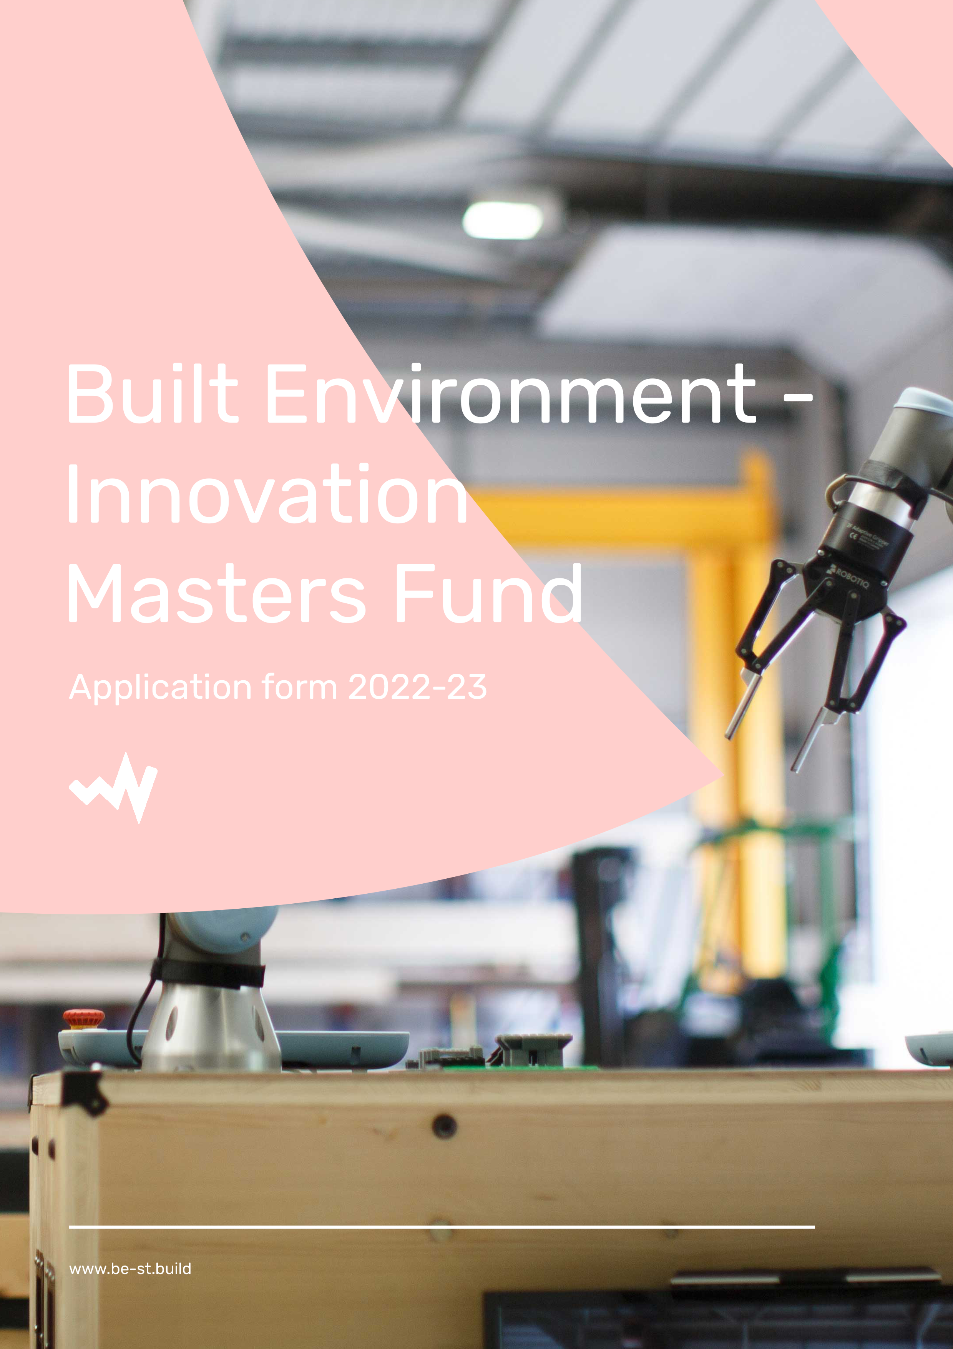

The Built Environment Innovation Masters Fund 2021-22

Built Environment - Masters Innovation Fund

Application form

Applicant details

Student Name
Are you a Scottish student and applying to a Masters level course within a Scottish Higher Education  Institute? | Yes / No
Which Scottish University
are you studying with /applying to

Please state if you are a full time or part time student

Education (highest level) grade
Name of Masters/MSc course that you are undertaking

Start date of your course (dd/mm/yy)

- Which areas of innovation within the built environment are you interested in
(tick all that apply)

Digitalisation | ☐
Engineering | ☐
Offsite manufacturing and processes | ☐
Modern methods of construction | ☐
Sustainability/zero carbon | ☐
Culture | ☐
Other (please specify) | ☐

- Personal Statement

Please explain why you are applying for the programme (<200 words)

What area of the built environment are you going to focus your research on?

- The scholarship requires you to work with an industry partner.
Would you be able to find your own industry partner or would you like us to help you finding one? Indicate yes or no below. If so, please specify the partners if known at this time.

I agree to work with an industry partner as part of my dissertation topic. (check box to agree) | ☐

Diversity monitoring

BE-ST strives to be an inclusive organisation. For us to do this we need your help in filling out a short monitoring form. None of the information provided will be shared with, or used by a third party. You can select ‘prefer not to say’ if you would rather not answer a question.
Your gender (please tick box)

Male | ☐
Female | ☐
Prefer to self-describe | ☐
Prefer not to say | ☐

Select your ethnic group (please tick box)

White | ☐
Mixed/multiple ethnic groups | ☐
Asian/Asian British | ☐
Black/African/Caribbean/Black British | ☐
Prefer not to say | ☐

Do you consider yourself to have a disability as defined by the Equality Act 2010? (please tick box)

Yes | ☐
No | ☐
Prefer not to say | ☐

Terms and Conditions
As stated, you must be a Scottish student to be eligible to apply. You will be informed by email whether you have made it to the next stage of the application process by the end of 2022. Admission to the programme will only be accepted when you have enrolled on an Masters level course at a Scottish higher education institute. You must agree to work with an industry partner. In some cases, applicants will be held on a reserve list and will find out if they have been successful later than the end of 2022.

I understand the Terms & Conditions as outlined above (please tick box) | ☐

Applying to the programme
Please download and return your completed application form to Kaye Keenan (kkeenan@be-st.build) before 30th November 2022.

Completing the application form
If you have any issues completing your form or wish to discuss your application further, please get in contact by emailing the following: kkeenan@be-st.build.

Data Protection
BE-ST collects and processes your personal data in order to provide you with the Build Environment masters fund application you have requested. We process your personal data in compliance with current UK data protection legislation and may share your personal data internally and externally as necessary, appropriate and required to administer and manage the effectiveness of the masters application fund.
For more information please read our online Privacy Notice which can be accessed using the following link: www.be-st.build/accelerate-to-zero/skills-competencies/the-built-environment-innovation-masters-fund/

